

Practices for Secure Software Report

Table of Contents
Document Revision History 3
Client 3
Instructions 3
Developer 4
1. Algorithm Cipher 4
2. Certificate Generation 4
3. Deploy Cipher 4
4. Secure Communications 4
5. Secondary Testing 4
6. Functional Testing 4
7. Summary 4
8. Industry Standard Best Practices 4

Document Revision History

Version | Date | Author | Comments
1.0 | [Date] | [Your Name]

Client



Instructions

Submit this completed practices for secure software report. Replace the bracketed text with the relevant information. You must document your process for writing secure communications and refactoring code that complies with software security testing protocols.

- Respond to the steps outlined below and include your findings.
- Respond using your own words. You may also choose to include images or supporting materials. If you include them, make certain to insert them in all the relevant locations in the document.
- Refer to the Project Two Guidelines and Rubric for more detailed instructions about each section of the template.

Developer
Austin Sprowls

Algorithm Cipher
I will be recommending AES-256 for Artemis Finacials archive data due to it being good at bulk data encryption while also being fast and have a relatively small cipher text size. A 256 bit key length will be able to protect against brute force attacks while key management will improve on that integrity by rotating primary, active, and inactive keys. AES-256 does present some risks such as permanent data loss if a key is lost and future improvements in computing technology could render this cipher algorithm unusable. The use of random numbers helps to create a unique digital footprint that helps verify data integrity, if any of the data was tampered with the hash would be slightly different. Furthermore, SHA-256 is great for collision resistance because that means that there are 2^256 possible hash values. Thus the bit level helps connect to the strength of security through brute force resistance.

Certificate Generation
Insert a screenshot below of the CER file.

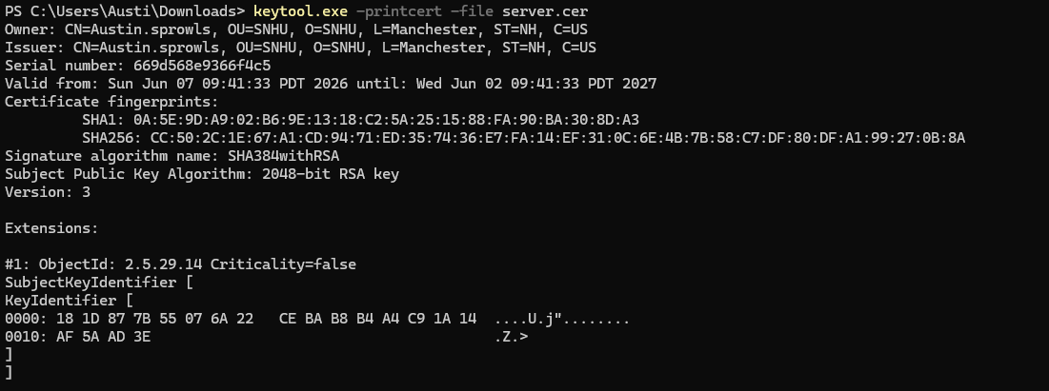
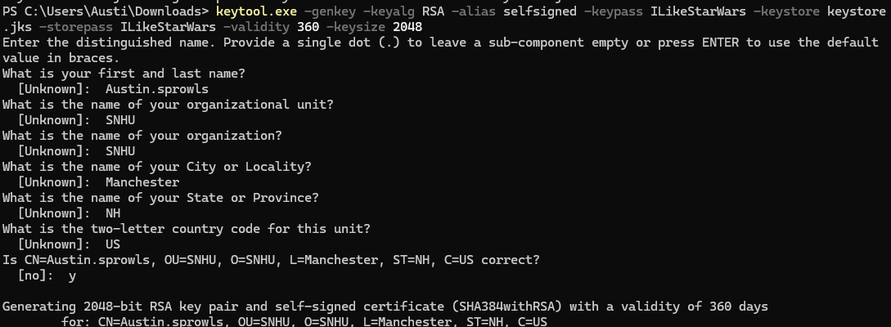

Deploy Cipher
Insert a screenshot below of the checksum verification.

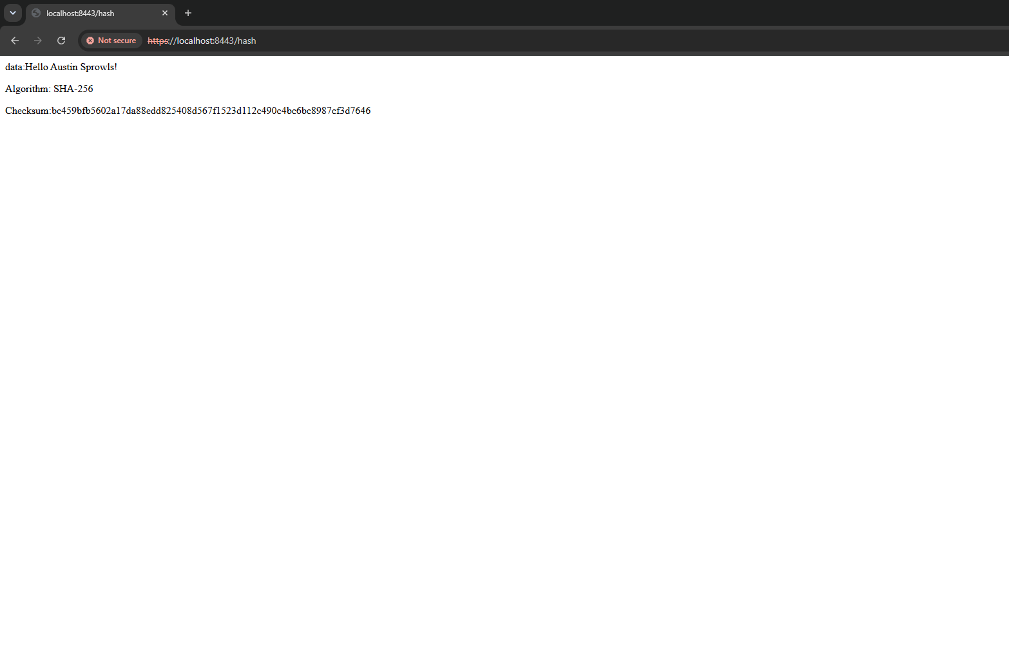

Secure Communications
Insert a screenshot below of the web browser that shows a secure webpage.



Secondary Testing
Insert screenshots below of the refactored code executed without errors and the dependency-check report.

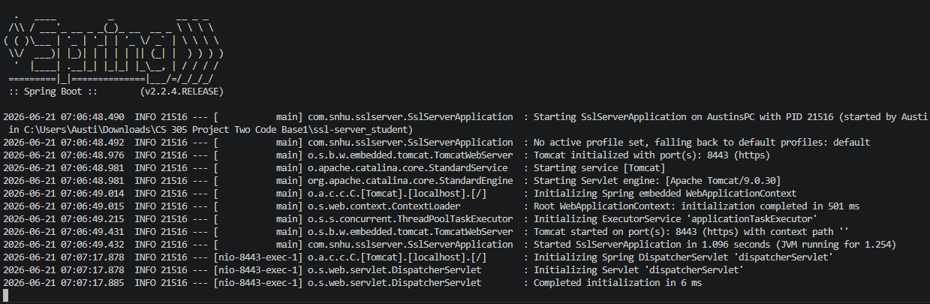

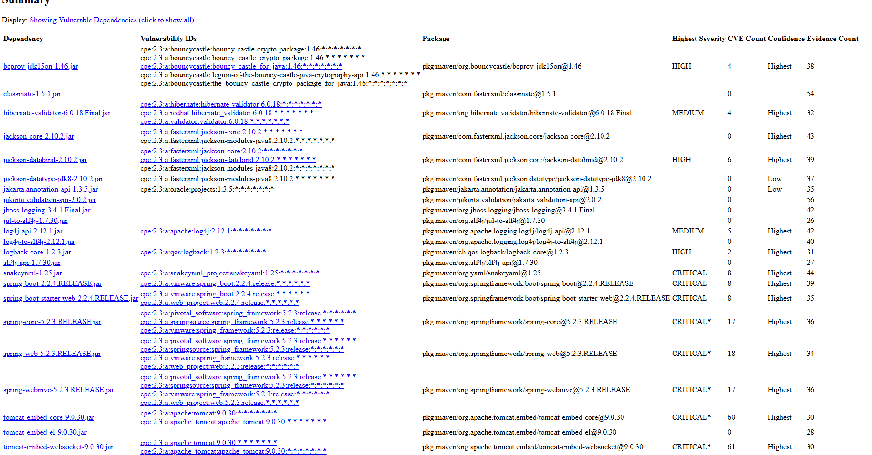

Functional Testing
Insert a screenshot below of the refactored code executed without errors.


This screenshot helps to demonstrate that the functional testing and refactoring was successful. The program runs without any errors. The code also works as intended after going to the https url I can find that sha-256 correctly hashes the data string. Moreover, HTTPs properly secures the connection between server and client although printing the stack trace could be a security concern. Furthermore, input validation is hard coded into the data string so reduce the risk of malicious input.

Summary
In summary the following security areas from the vulnerability assessment process flow diagram were addressed through refactoring. First is Cryptography I implemented SHA-256 checksum with a self signed certificate. Client/server was the next security area that I addressed converting the HTTP to HTTPs which created a secure connection from server to client. REST API endpoint was added to help return the encrypted data. Lastly code quality was used to ensure that secure coding practices were used and java security libraries were added.

Industry Standard Best Practices
Throughout this project I used a variety of industry standard best practices to enhance the security of this program by refactoring the code using the following. First SHA-256 was used because it was made the industry standard by the NIST therefore making it appropriate for this use case. Furthermore, the use of HTTPS is also the standard as HTTP does not secure the connection between client and server therefore creating a need for HTTPS which was used to make the security for Artemis Better. Javas built in security libraries allowed me to efficiently use cryptography without creating my own with updates and other features. For a test environment I opted for a self signed certificate specifically because they are easy to obtain and use only in a test environment but should not be used outside of the testing environment. Lastly I used dependency checks to see if there were any known and publicly disclosed vulnerabilities within the dependencies of my project by checking against those specific vulnerabilities.

Using industry standard best practices is beneficial to the well being of Artemis financial for the following reasons. First it allows users to trust that the company will keep their data secure and protected while also respecting their privacy. Furthermore, Artemis Financial will be kept within regulatory compliance by using the most up-to-date security practices and strategies. The combination of these things will help Artemis stay out of legal trouble as they are at the forefront of reducing breaches and staying ontop of security which connects to their missions statement that “security is everyone’s responsibility”.

